The goal of this study was to investigate pricing approaches for Big Mountain Resort, utilizing a predictive model to determine the optimal ticket price that will increase revenue by 10% the following season, while staying competitive in the market. The aim was to present practical suggestions for tweaking prices or making infrastructure improvements to boost revenue. The data preparation stage was important for creating a solid base in which exploratory data analysis (EDA), modeling, and scenario planning will be performed. This stage focused on ensuring the data was clean, relevant, and robust, which is important for extracting precise insights and developing a reliable predictive model. Key steps in the data preparation included managing missing values, eliminating duplicates, confirming data type uniformity, extracting relevant features, spotting outliers, guaranteeing data representativeness, verifying the data, and thorough documentation. For example, the table below displays the amount and the percent of data points that were missing values for each feature.

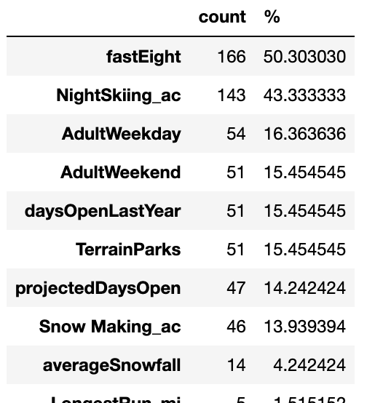

The EDA provided crucial insights into the ski resort industry, showing how different resort attributes correlate with ticket pricing. Visualization techniques helped pinpoint features influencing ticket prices, such as vertical drop, snow-making capabilities, and the quantity of fast quad lifts. Also, this analysis helped give us a deeper understanding of the market and customer preferences, assisting in strategic decision-making. Below are plot illustrations of the features with the highest price correlation.

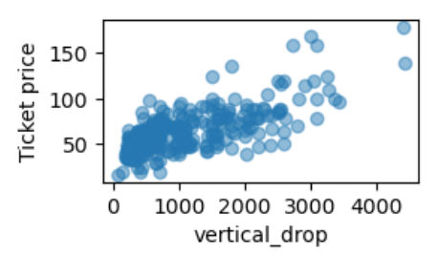 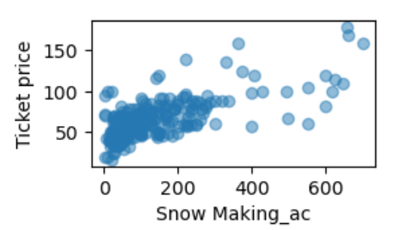 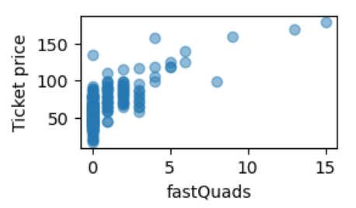

Through feature engineering, the model's accuracy in forecasting was significantly improved by developing new variables and focusing on essential features. This enhancement helped standardize the data, filling in missing values with the median method, and pinpointing key predictors such as features. The study used linear regression and random forest techniques to create the models. Their effectiveness was measured using evaluation metrics like R-squared, Mean Absolute Error (MAE), and Mean Squared Error (MSE), all of which assessed the models' precision in predicting ticket prices from several resort characteristics.

Ultimately, the random forest methodology outperformed the linear regression model in terms of predictive precision and stability. Many business strategy simulations were carried out to evaluate their possible impacts, including the closure of select ski runs or the expansion of snow-making capabilities. Below is the Random Forest Model graph displaying the features correlation to ticket prices in descending order.

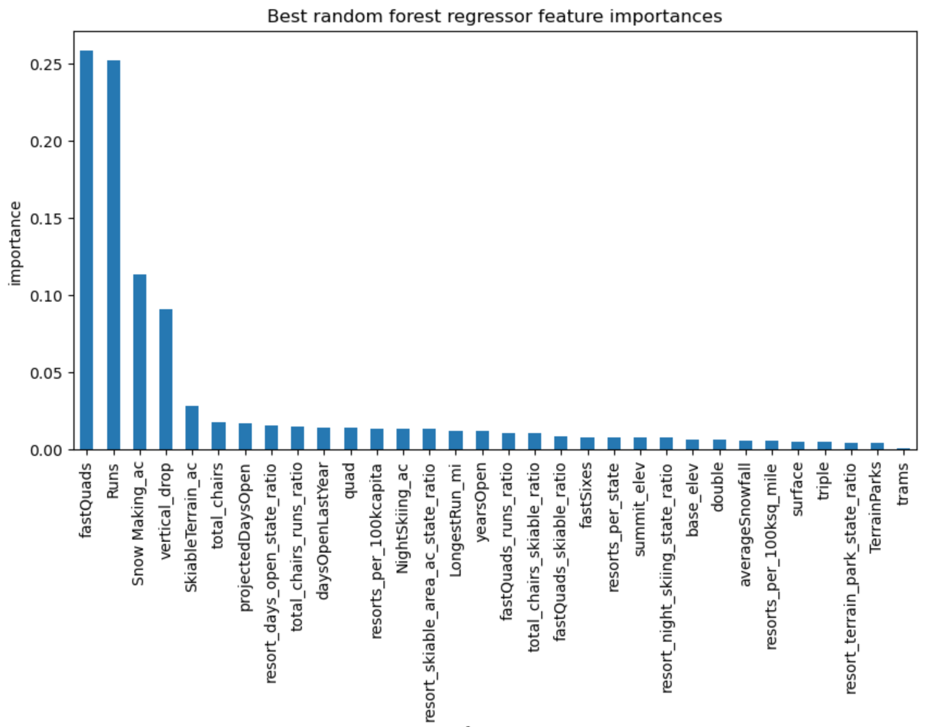

The study suggested raising the ticket price to $95.87 from the existing $81.00, given Big Mountain's market standing and amenities. With an anticipated mean absolute error of $10.39, this price revision could significantly enhance revenue, possibly adding as much as $3,474,638 throughout the season. Below are bar graphs displaying these market standings, such as for national/state weekend ticket prices, as well as key features such as vertical drop and snow covered area in acres.

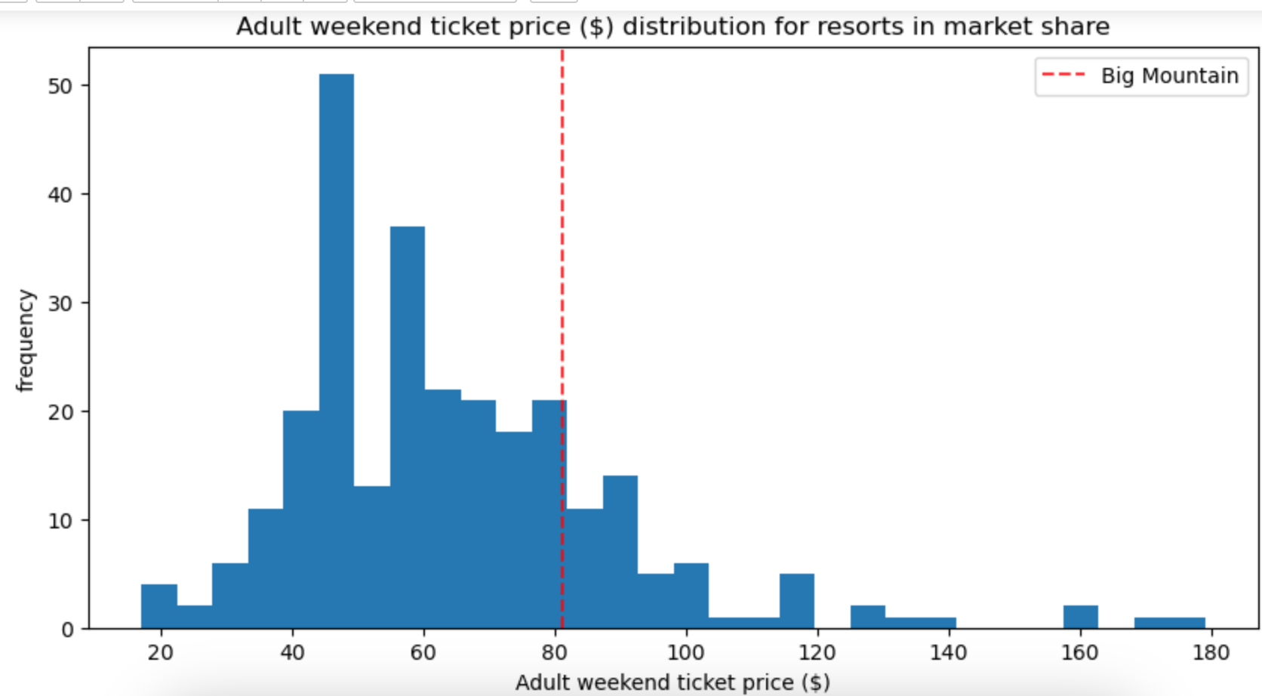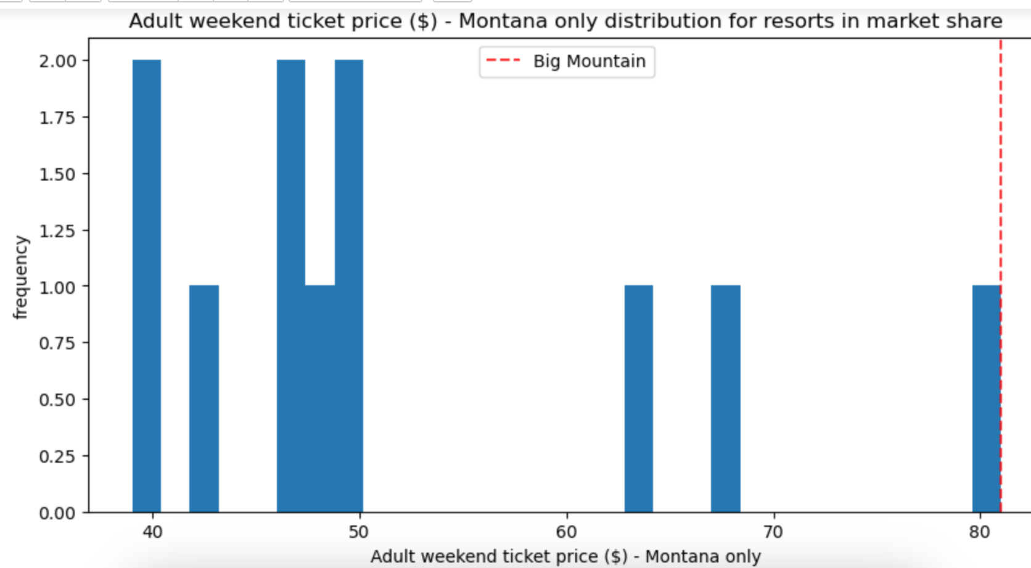

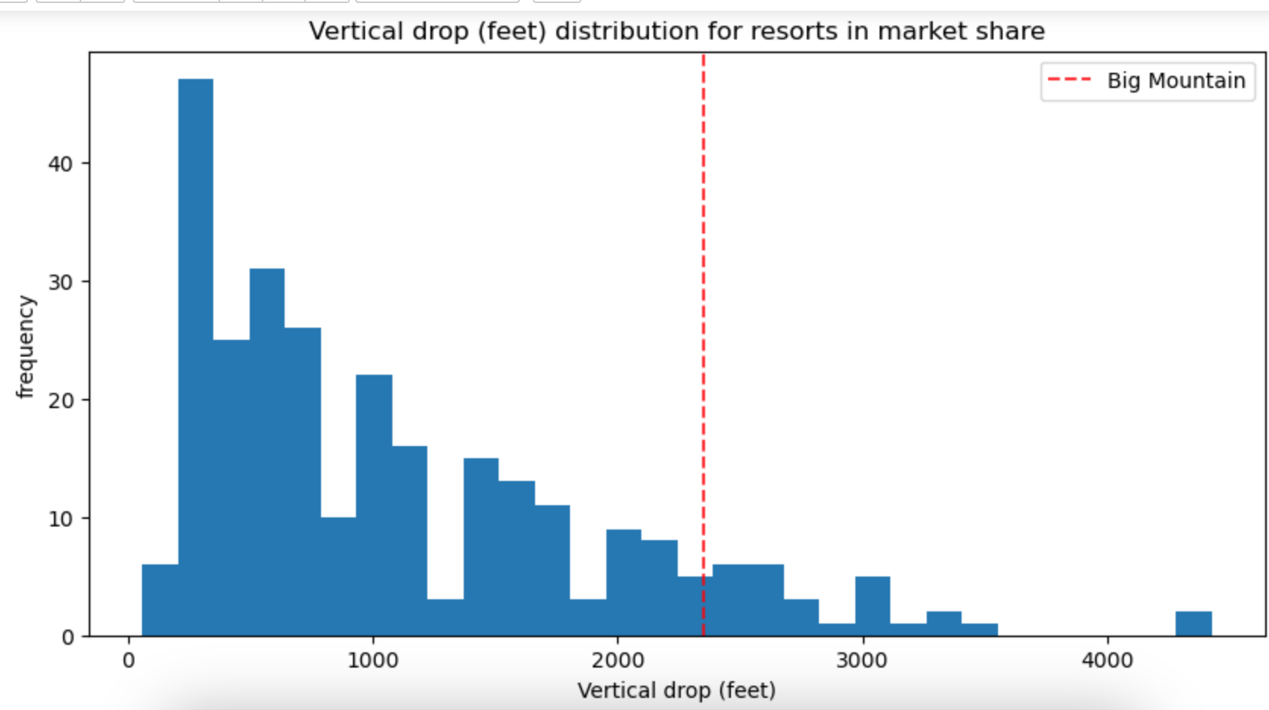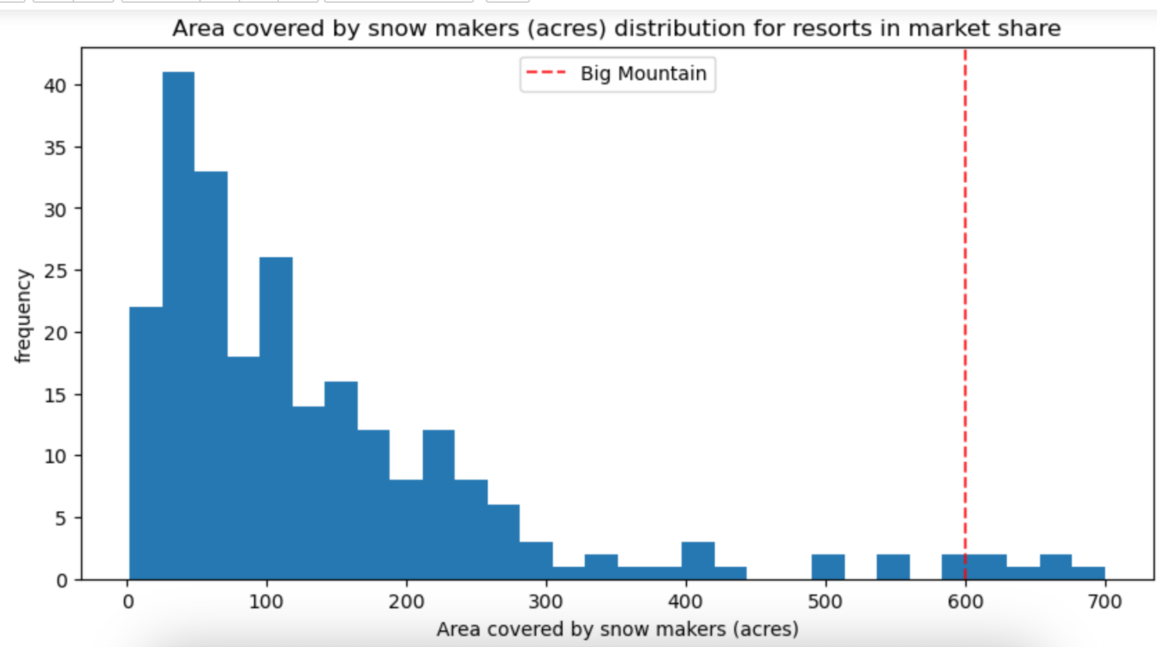

The analysis confirmed that Big Mountain Resort has the potential to increase its ticket prices. By adopting the suggested price changes, the resort could boost its revenue while staying competitive. Future studies could expand on this by including more diverse data, like customer demographics or other economic factors, to further hone the pricing strategy. Finally, investigating how demand fluctuates with price changes could provide additional valuable insight.